**Program Homework #4 (Due PM: 5:00, March 29, 2019)   
The design of a Complex number object**

* **Goal**  
  This program is provided for you to learn how to design a functional complete object for the complex number. An initial template is provided for you to write the program that are yet to be finished.
* **Requirement**

1. Please finish the program segment in the complexi.cpp, such that the main.cpp can be executed. When you execute the complex.exe < input.txt in the command window, you will get the following output  
     
   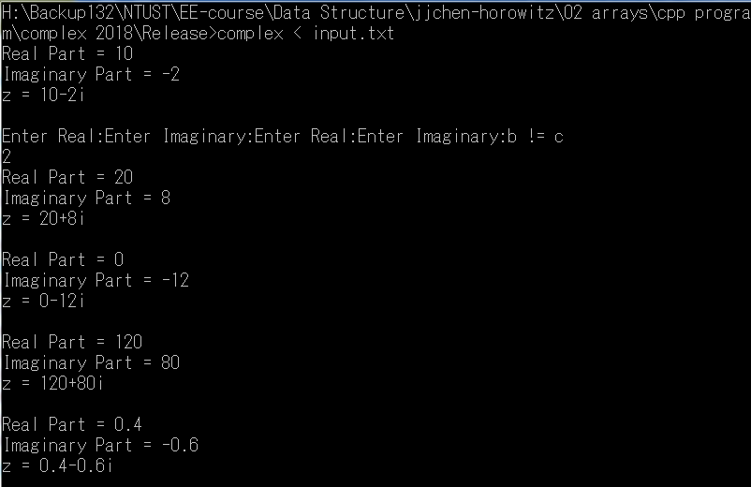

* **Steps:** 
  1. Please double click the file complex.sln and modify the program complexi.cpp.
  2. when building the entire project, please set to “Release” Mode.
  3. Execute the program at the Release directory on a command window:  
     complex < input.txt > output.txt
  4. You can check the correctness of your program by the output.txt.
  5. Write a simple report of your work. This is required for us to identify your contributions.
* Note: Everyone is encouraged to write the program from scratch by yourself.